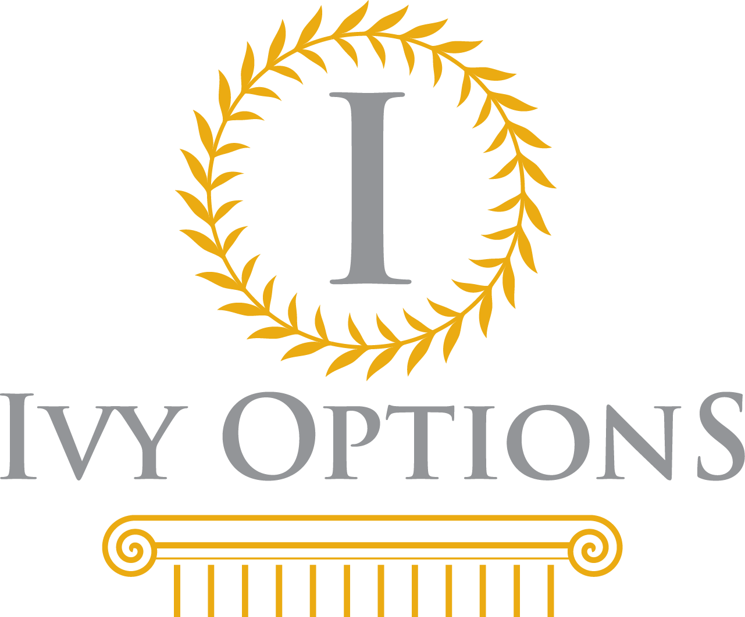

Company: Ivy Options
Job Title: University Admissions Counselor
Position: Full-Time
Location: Dubai, United Arab Emirates
Salary Range: $50,000 to $100,000 per year (tax free) - commensurate with qualifications and experience

Ivy Options, a Dubai-based university admissions consultancy, seeks an independent and motivated admissions counselor who is interested in working with international high school students to help them shape their academic goals and guide them through the college application process. You will work independently and as a team member with the company’s other consultants to guide students and parents through the maze of college admissions and help them find the best fit.

Job Responsibilities:
· Meet with students regarding all aspects of the university application process.
· Help students create a balanced university list.
· Help students brainstorm essay ideas.
· Revise and edit student applications, resumes and essays.
· Help students create a roadmap and action plan for each university.
· Assist students in filling out the Common Application and other applications.
· Advise students on academics (course selection) and extracurriculars to maximize their potential.
· Create a standardized testing timeline for each student.
· Research and advise students on suitable summer programs, courses or camps.
· Assist students with their summer activity applications.

Job Requirements:
· Native English Speaker
· Bachelor’s degree from a reputable US, Canadian, or UK university
· 2-5 years of experience in university admissions preferred
· Passion for higher education and helping students
· Professional managerial and relationship-building skills
· Strong creative and strategic thinking ability
· Excellent editing and writing skills
· Attention to detail
· Presentation skills in both individual and group settings
· Comfortable with computers and internet research

Company Information
Dubai-based Ivy Options is a boutique university admissions consultancy. The company provides highly individualized academic and university application guidance as well as ACT and SAT preparation and American university tours. We specialize in helping international applicants and American students abroad who face unique challenges when applying to universities in the U.S. and elsewhere in the world. Ivy Options helps students showcase themselves and be the best applicants possible. The staff consists of professionals and former admissions officers from some of the most selective colleges and universities in the world.

In 2018-19, we have already helped students achieve acceptance into some of the most competitive universities in the world, including Columbia University, Cornell University, Dartmouth College, MIT, University of Chicago, NYU Stern, University of Cambridge, University of St. Andrews, University College London, London School of Economics, Imperial College London, McGill University and University of Toronto.

